Group member: Zheng Yin(V00915261), Chenghaoliu (V00841275)
- 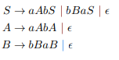
The PDA P= (Q, Σ, Γ, δ, q0, Z0, F) is defined as
Q = {q}
Σ = {a, b}
Γ = {a, b, S, A, B}
q0 = q
Z0 = S
And the transition function is defined as:
δ(q, ε, S)={(q, aAbS),(q, bBaS), (q, ε)}
δ(q, ε, A) = {(q,aAbA), (q, ε)}
δ(q, ε, B) = {(q, bBaB), (q, ε)}
δ(q, a, a) = {(q, ε)}
δ(q, b, b)= {(q, ε)}

2. (20 Marks) Convert the following PDA to a CFG using the construction given in class
Solution:
V = {A00, A11, A22, A33, A01, A02, A03, A12, A13, A23}
A00 —> A00A00 | ε
A11 —> A11 | ε
A22 —> A22 A22
A33—> A33
A01 —> A00A01 | A01A11
A02 —> 0A12 | A11A12
A03 —> A11A12
A12 —> A12 | ε
A13 —> A12A23
A23 —> A22A23
3. 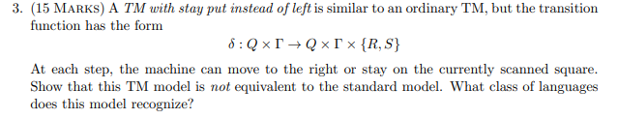
Solution:
We can simulate any DFA on a Turing machine with stay put instead of left, and the only modification we need to do is adding transitions from state in F to q_accept until reading a blank and from state outside F to q_reject upon reading a blank.
Now, we set a TM M = (Q, Σ, Γ, δ, q0, q_accept, q_reject) with stay put instead of left, and we can create a DFA(Q’, Σ’ , δ’ , q0’ , F) that can read the same language. The intuition here is that M cannot move left and cannot read anything it has written on the tape as soon as it moves right, and it has only one way to get its input.
Add a new symbol that M can not write blank on the tape, instead, M writes the new symbol when it needs to write blanks. And extend the transition function so that upon reading this new symbol, it behaves as though it read a blank. And when M transition reach q_reject or q_accept, the head moves right.
So Q’ = Q, Σ’ = Σ, q0’ = q0
δ’(q, σ) = q, if q is in the set of {q_accept, q_reject}
δ’(q, σ) = q_reject if head start at q and read σ.
δ’(q, σ)= q’, if where q’ is the state M enter when it moves right before start and read σ.
Then we can get a DFA that is equivalent to this TM.

4. (a) To prove two language is decidable language under concatenation, we set L1 and L2 be two Turing decidable language, the concatenation is L1L2. Now we have an input S, so S = L1L2. Now run the respective Turing machines of L1 and L2 on tape 1 and tape 2. If both accept then it is accepted, else it is rejected.
(b) To proof for decidable language is closed under intersection.
Only if both TMs accept, then the operation accept. So, we can run the TMs of L1 and L2 one after other.
(c) To proof for decidable language is closed under complementation.
As we know, to design a machine for the complement of a language L. we need to create the machine of L on an input. If L is accepted, then machine reject and vice versa.

5.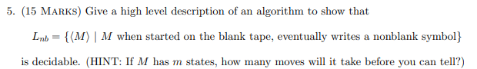
If we create a TM M’ which generate by the code for TM, and we get m as the states number of M. Then simulate M on the black tope until m moves. If there is a non-blank symbol is written by M, the L_nb is accepted. By construction this is a halting machine, and if M is not in the set of L, then M is also not in the set of L(M’). By other word, if M is in the set of L, then there will be a non-blank symbol after j transitions. These transitions must start in j distinct states, otherwise we contradict the definition of j. If j <= M, then the TM M’ will accept. So the L_nb is decidable.

6. 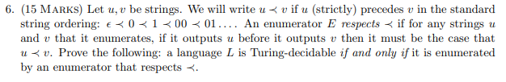
If L is decidable by some TM M, the enumerator operates by generating the string in the standard string ordering, testing each in turn for membership in L using M, and printing the string if it is in L.
If L is enumerable by E in standard string ordering, we can consider two case, if L is finite, it is decidable for all finite language are decidable.
And if L is infinite, M that decide L will operate like this:
On getting input w, M runs E to enumerate all string in L in the standerd string ordering until some string lexicographically after w appears. This must happened for L is infinite. If w has appeared in enumeration already, then accept, else reject.

